Downloading Documents

With Google Docs
Google Docs has two ways to download a document. A document can be downloaded while a document is open or a document can be exported from the All Items list. Both ways will be covered in this tutorial.

While the Document is Open

- Click the File tab. A drop down list will appear. Click Download as. Click Word. For spreadsheet files click Excel. For PowerPoint files click PowerPoint. A File Download window will open.

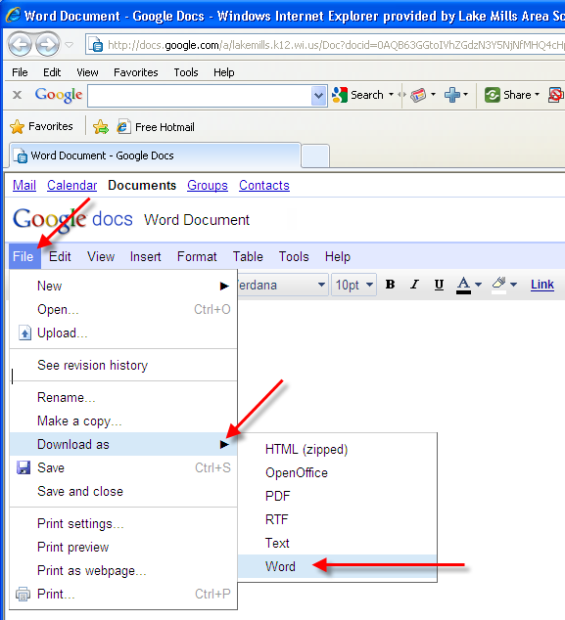
- Click the Save button to save the document. A Save As window will open.

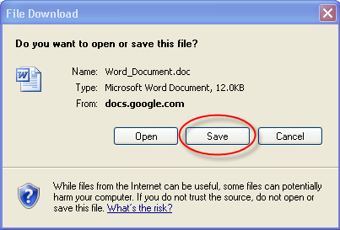

- In the Save in field, click on the down arrow and select a destination to save the file to. In the File name field, type in a new name if desired. Click Save to start downloading the document.

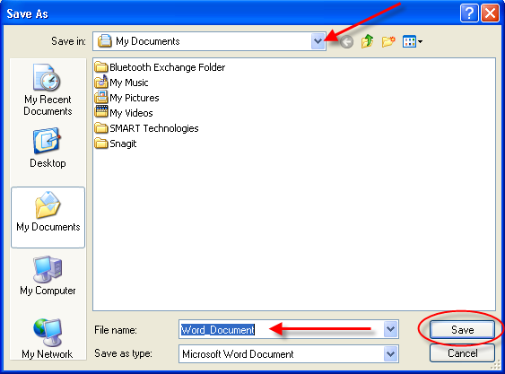

- When the download is complete, click the Close button.
While the Document is Closed

- In the All Items list view, select a document to export by clicking and checking the empty box. Click on the More actions tab, a new drop down list will appear. Click Export. A new Convert and Download window will open.

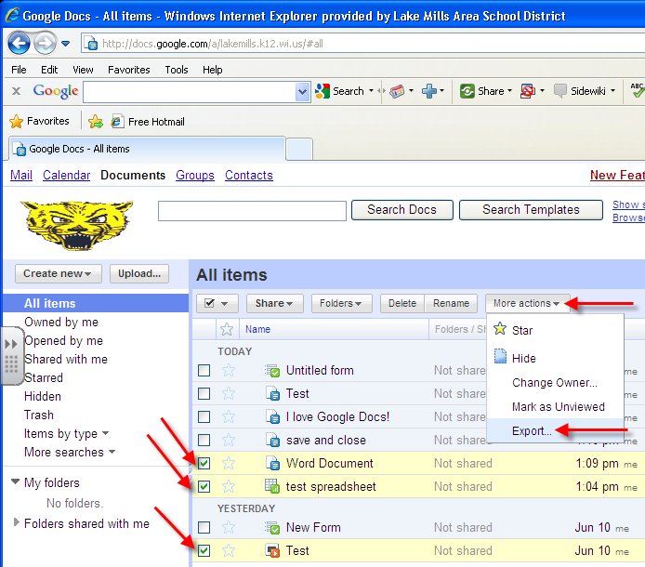

Note: One or more types of documents can be selected and exported at a time.

- At the top of the Download and Convert window, make sure the Selected items tab is selected. Next to each of the selected documents, click on the down arrow to reveal a drop down list of available file formats. For word documents, most users will select Microsoft Word. For presentation documents, most users will select PowerPoint. For spreadsheet documents, most users will select Microsoft Excel. When finished, click the Download button.

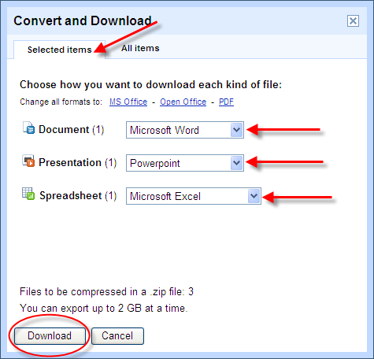

- A Zipping window will open to show you the loading process. If the download does not automatically start, then click on click here to start download.

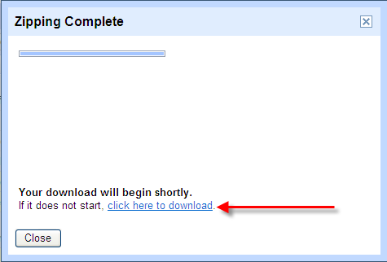
- A File Download window will open. Click Save. A Save As window will open.

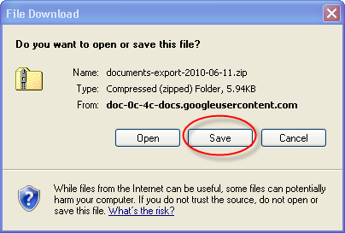

- In the Save in field, click on the down arrow and select a destination to save the file to. In the File name field, type in a new name if desired. Click Save to start downloading the document.

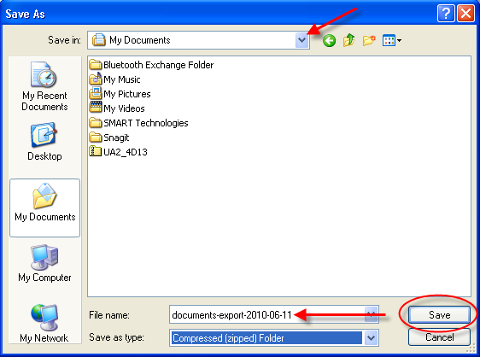

- When the download is complete, click the Close button.
- If a single file was downloaded, the file will be downloaded as the selected file type. If multiple documents were downloaded, all of the documents will be saved in a Zipped Folder. Double-click the folder. Click File, a drop down list will appear. Click Extract All.

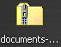

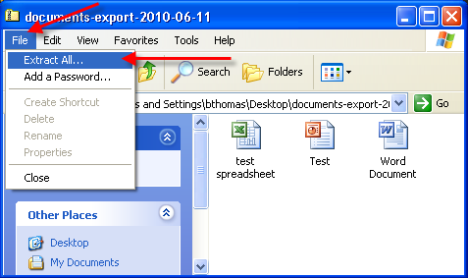

- Click Next.

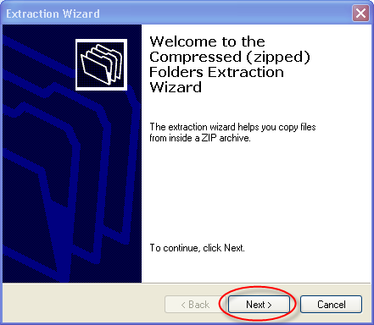
- Click Next.

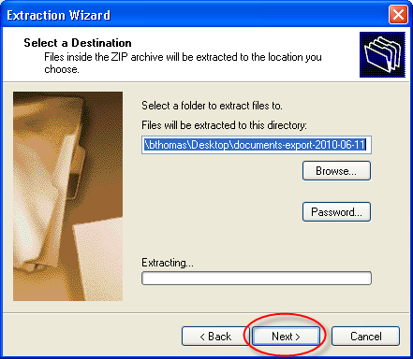

- Click Finish to extract all of the files.

